|  |  |  |  |  |
| --- | --- | --- | --- | --- |
| Spacelabs Healthcare | | NUMBER: 082-0196-00 | | REV A |
| Software Specification | | PAGE: 1 | OF |  |
| ORIGINATOR: | Valeriya Kholodkov | | | |
| SUBJECT: | Software Specification for Data Exporter | | | |

Revision History

|  |  |  |  |
| --- | --- | --- | --- |
| Version | Date | By | Description |
| 1.0 | 22 Jan 2009 | Valeriya Kholodkov | Initial Draft |
| 2.0 | 14 Oct 2011 | Krishna Saroja | Revised from Project Profile feedback |
| 3.0 | 11 Apr 2012 | Richard Dill | Update to reflect change in User Interface |
|  |  |  |  |
|  |  |  |  |
|  |  |  |  |

Table of Contents

1. Description 3

2. Description of the Elements 3

2.1 Data Exporter 3

2.2 Data Source 4

2.3 CMessage Box 4

2.4 Helper 4

2.5 Logger 4

3. Tables for the Data Extraction 4

3.1 Tables from which data is extracted by patient 4

3.2 Tables from which all data is extracted 4

4. Export Data 4

4.1 Entering Tool Password 4

4.2 Connectivity Info dialogue 5

4.3 Data Exporter v1.0 Dialogue 5

4.4 Unique file Id for Extracted data 6

4.5 Information dialogue 6

5. Export Waveform: 7

5.1 Data Exporter v1.0 dialogue: 7

5.2 Unique File Id for Extracted waveform data 8

5.3 Information Dialogue 8

5.3.1 StartFT and EndFT: 9

5.3.2 Sample Count: 9

# Purpose and Scope

The Data Exporter tool is a Microsoft Windows application designed for exporting waveform and vitals related data from an ICS G2 database to flat files without patient identification. Its use allows “raw” data availability for analysis during software debugging or “research into what happened” events that are occasionally reported/requested. It “reads” data from the ICS G2 database tables and does not modify any of the original data state except for the removal of patient identification information.

The set of tables for data extraction is configurable through an application configuration file. Setting in this file can be configured to extract data from a table for a single patient otherwise all table data will be extracted into the output file.

This document specifies the high level components design and extendibility of the Data Exporter application.

# Description

Data Exporter block diagram identifies the different components used as part of application.



# Description of the Elements

## Data Exporter

## Data Source

Data Source component is designed to handle database connection data verification, patient search by Unique Identifier and Last Name.

## CMessage Box

CMessage Box component is custom created message box. The component is used for displaying different type of messages.

## Helper

Helper component is designed to retrieve and handle application xml based configuration processing.

## Logger

This block has functionality of creating and appending application log file. Logger component handles capturing different type of messages into log file.

# Tables for the Data Extraction

## Tables from which data is extracted by patient

int_waveform

int_patient_channel

int_param_timetag

int_result

int_savedevent

int_SavedEvent_Waveform

int_savedevent_vitals

int_savedevent_beat_time_log

int_savedevent_calipers

int_savedevent_event_log

int_channel_type

int_alarm

int_alarm_waveform

## Tables from which all data is extracted

int_misc_code

# Exporting Data

## Entering Tool Password

“GTSwave” should be entered as password in order to proceed with the application.

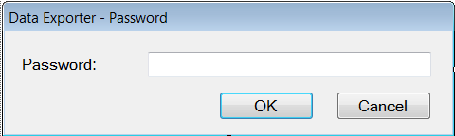

Application will prompt user to enter ICS/G2 database connection information.

User will be prompt for database connection information again then it’s required if “Connection Info” form is dismissed by selecting cancel button.

## Connectivity Info dialogue

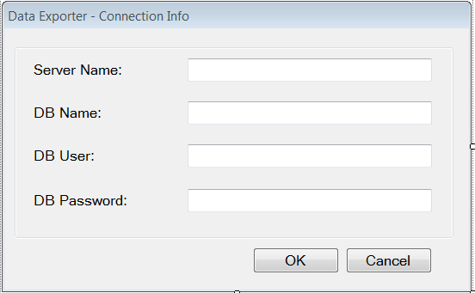

## Data Exporter v1.0 Dialogue

Data extraction can be performed only if patient is selected. The user will need to search for patient by unique identifier or last name. Search is not case sensitive and may display multiple patients in the Patient drop down. An appropriate patient should be selected.

Path defines the folder location where the extracted data and application log files will be stored. Spaces in folder name and path are not allowed.

Extract the data by clicking on button “Export Data”.

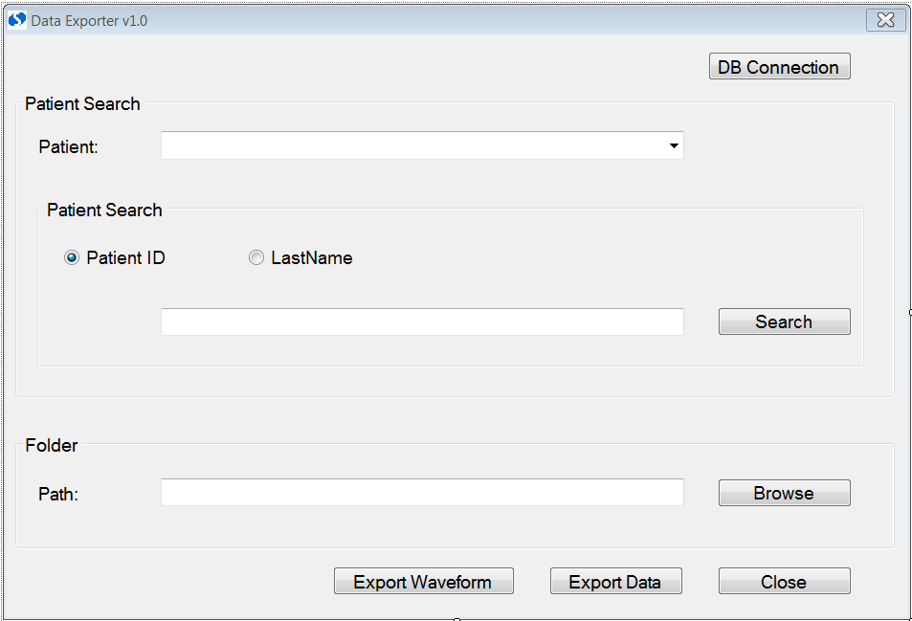

## Unique file Id for Extracted data

The system will prompt the user to enter a unique identifier which identifies each set of extracted files. This Unique ID can be any alphanumeric string. The Unique file id helps to identify each specific set of exported files so that multiple sets of files can be stored at in a single folder location.

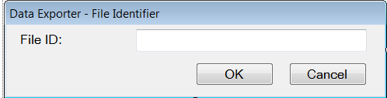

After the data extraction has completed the log file should be checked for proper export operation.

# Exporting Waveforms:

## Data Exporter v1.0 dialogue:

Patient waveform data is stored in the database for each channel (parameter), and there might be cases where a patient is connected to more than one ECG channel (ECG, ECG1 etc...) and also a case to generate more than one ECG parameter (ECG,ECGa,ECGb etc...), Because of not discharging the patient at one monitor and trying to admit the patient in another monitor.

Each channel’s waveform data is stored as data records in int_waveform table.

For a given patient and for a given channel, waveform data records are extracted ordered by time and appended together. The resultant waveform data is then exported to a binary file. The process is repeated for each channel type for a patient.

Along with the binary files a log file named WaveformSampleInfo.txt file is created. The log file contains the channel – binary file mapping information and other miscellaneous data like sample count and start and end time.

Just like data extraction described above, waveform extraction can be performed only if a patient is selected.

Path defines the folder location where the extracted data and application log files will be stored. Spaces in folder name and path are not allowed.

## Unique File Id for Extracted waveform data

To export waveform data click on the “Export Waveform button”. The user will be prompted for file unique identification. This identifier uniquely identifies the exported files for each session.



After the waveform extraction has completed the log file should be checked for proper export operation.

### **StartFT and EndFT:**

For a given channel each data record in the table will have a start and end timestamp. Of all the available data records the minimum of start time stamp is considered as StartFT. And the maximum end time stamp is considered as EndFT.

Note: In WaveformSampleInfo.txt StartFT and EndFT are file time in UTC format.

### **Sample Count:**

Sample count is derived from the following expression

(EndFT - StartFT) * Sample Rate

To make file unique append the current date time to the WaveformSampleInfo.txt and exported binary files.